**How the Web works**

**How does the Internet work?**

As we know the Internet is the backbone of the Web and it is a large network where computers are connected and able to communicate. In the history of the Internet, it started in 1960s were in it was used in the US army and in the 1980s it was also available to be used in public infrastructures.

**Why is the Internet called ‘a network of networks’?**

If you wanted to connect your computer to another computer you must first link them, either physically or wirelessly. A network is not just limited to two computers that are connected instead a network consists of other networks. This means that you can be able to connect multiple computers using cables.

It will be cumbersome to connect and wire let say 10 computers, this will produce more than 40 cables. But what if you connect a computer to a device which can connect other computers. This device is called a router, its job is to make sure that messages within the network is being sent correctly and delivered at proper destination. When you have a router that has 10 pots it will be easily for you to setup your network because you will only need a single cable for each node or computer.

**Is the Internet and the web the same thing?**

We now know that the Internet a large network and it is an infrastructure while the web is service that users can use to connect and communicate to other users that are also connected in the web.

**Webpage, Website, Web Server, Search engine**

**webpage** – A webpage is a document which is displayed in a web browser like Google Chrome, Firefox, Opera or Edge. A webpage is written in a markup language called HTML. Web pages can be access using addresses which you can place in your web browsers address bar.

**website** – This is simply a page which contains webpages. These webpages are then linked to each other using hyperlinks which allows users to move from one page to another.

**Web server** – A web server is a node or a computer that can host multiple websites. A web server sends web pages to users who access its website. All files that contains the content of a website is inside a webserver.

**Search Engine** – A search engine is a website used to browse and search for webpages and other websites. Some examples are Bing, Yahoo, Google and DuckDuckGo. These search engines enable users to query in the search engine and able to look contents in the web.

**What is a URL?**

Uniform Resource Locator (URL). URL contains unique name and it is also a unique content on the web. It can contain an html document, css document, videos, audio or even images, etc.

A URL has different parts:

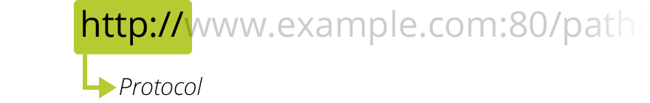

The protocol tells what kind of protocol must the browser use. It can be the secured version of HTTP which is HTTPS or other protocols like ftp and others.

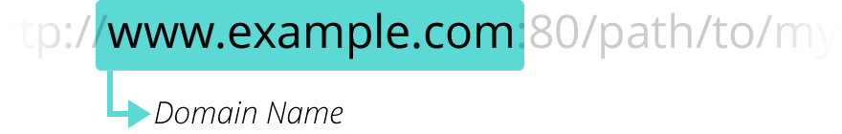

The Domain name is the address in which a web server is located. You can also use the IP address of a web server to locate a website in the web.

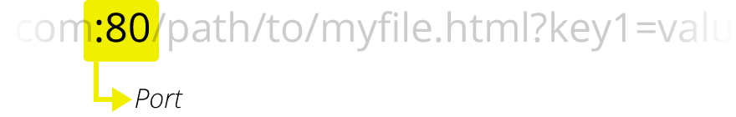

A port is used to access a resource on a web server. It is like a gateway where you can know where to find a certain resource.

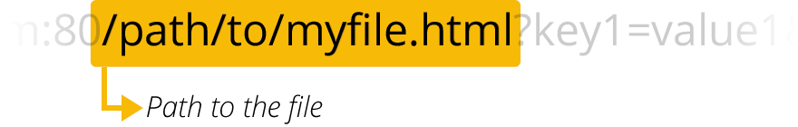

This path is where you locate contents of a web server just like in windows explorer where path can be directories and inside the directory are sub directories. This can be used to point to a specific resource in a web server.

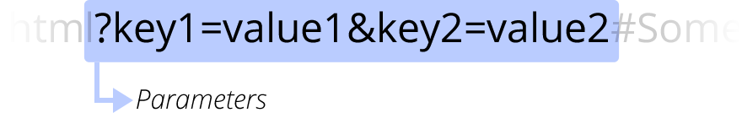

This values are parameters that are given to a web server where these parameters can do other thing before it can deliver a resource to a user.

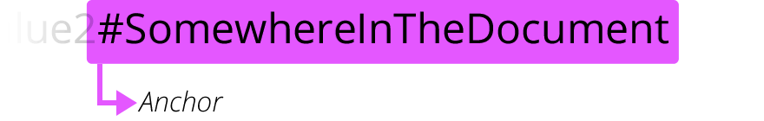

An anchor represents a bookmark in a resource on a webpage. This serves as a linked to a location that is bookmarked in a resource. When a bookmark is selected in a webpage it will scroll through the webpage that contains the anchor. Another example is a video where you can click or point to a certain point of the video or audio.

**Absolute URL and Relative URL**

To differentiate and understand what and absolute and relative URL is examples will be provided.

**Examples of absolute URL**

Full URL

<https://example.org/docs/topic>s

<https://example.org/docs/topics/topic1>

Implicit protocol

//example.org/docs/topics

Implicit domain name

//docs/topics

This shows that absolute protocol fetches its resource from the root directory. Where you must specify the location of a resource which you want to access. You can also easily identify an absolute URL if it uses the “ / ” character.

**Examples of relative URL**

Example if this URL is entered https://example.org/docs/topics

Assuming you wanted to access a sub-resource located in /topic1/part1. You will not need to type in every directory to point to that resource. Using relative URL and because the URL does not start with the “ / ” character the browser will attempt to find the resource. So what we really wanted to locate is the address <http://example.org/docs/topics/topic1/part1>.

What are Domain Names?

Domain names are human readable addresses in the web and domain names uses semantic URL in which users can easily remember a resource in the web. Users can access any website using IP address of a website but this will be hard for people to remember a lot IP addresses because IP a single IP address contains 32 bits for IPv4. (eg. 192.168.1.1)

Domain name Structure

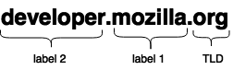

TLD (Top-Level Domain)

TLD provides user information about what service does a website server (eg. .com, .org, .net, .ph, .us etc)

Label (or component)

This contains any letter or word and can be referred to as a Secondary-Level Domain

Reference:

https://developer.mozilla.org/en-US/docs/Learn/Common_questions#How_the_Web_works